WEB AND MULTIMEDIA DEVELOPMENT ASSIGNMENT 2026

1. Website Specifications
1.1 – Website Objective
The objective of this project is to design and develop a Qatar Airways Fleet Wallpaper website where aviation enthusiasts can browse and download HD wallpapers. This will be featuring different aircraft that this prestigious airline uses to fly millions of passengers annually. The website is based on the interests of the avgeek community, particularly those who appreciate the airline and enjoy aviation-related content. It will serve as a centralized digital platform that extends my existing aviation fan community on Instagram into a more structured website.
The project also aims to demonstrate the full website development process required for this assignment, from planning and information design to implementation, testing and publishing. In overall, the website is meant to provide a user-friendly and visually appealing experience for aviation enthusiasts and other visitors in general who have an interest in aircraft and airline media. This middle east giant of an airline has created a great reputation for itself over the years winning the prestigious Skytrax "World’s Best Airline" title a record nine times, according to 2025 data. The airline secured this top recognition in 2011, 2012, 2015, 2017, 2019, 2021, 2022, 2024, and 2025. Therefore this website will definitely be a hub for the strong fanbase.

1.2 – Business Goals
- To extend my existing Instagram aviation fan community into a dedicated website where my followers can access wallpaper content in a more organized way.
- To increase the interaction with aviation enthusiasts by offering wallpaper categories long requested, based on different Qatar Airways aircraft.
- To simulate the sale and download of digital wallpapers for academic purposes as part of the assignment.
- To present the Qatar Airways fleet in a clear and structured way so that users can easily browse wallpapers by aircraft type.

1.3 – Target Audience
The target audience for this website consists mainly of aviation enthusiasts, plane spotters and followers of my existing Qatar Airways fan community on Instagram. These users are likely to be teenagers and adults according to my professional dashboard insights on the app. This is especially those between the ages of 18 and 40, who have a strong interest in aircraft, airlines and aviation photography. Due to the fact that the fan community is online, the audience comes from different countries and backgrounds, making the website suitable for an international audience.
In terms of the technical aptitude, the target users are expected to have basic to moderate digital skills. Most of them should be comfortable using websites, browsing image galleries, navigating menus and downloading digital content on both mobile phones and desktop devices. Many users may access the site through Instagram therefore it should be simple to use, responsive and even easy to navigate.

1.4 – Type of Website
This website is mainly a multimedia gallery website simply because it focuses on displaying and organizing aircraft wallpapers in a visual and user-friendly way. However, it also includes e-commerce simulation features, since users will be able to select wallpapers and go through a mock download or a purchase process. For this reason, it can be described as a multimedia gallery website with e-commerce elements.

2. Information Design & Taxonomy
2.2 – Information Architecture
The information architecture of this website is designed to organize the content in a way that makes it easy for users to find the wallpapers they would want. Since the website focuses on the Qatar Airways fleet, the content will be grouped according to aircraft types and arranged into their own clear sections. This will help users browse the website more easily.
The website will follow a hierarchical structure starting from the homepage and leading to the main sections such as the fleet gallery, the about page, the download or mock checkout page and the feedback page. This structure makes it easier to navigate and understand.
So since the website is intended for aviation enthusiasts and my Instagram fan community, the content should be easy to access. Users should be able to move from the homepage to a wallpaper category, then to a specific aircraft page and finally the download section without difficulty. This will make the website simple, structured and user-friendly.

2.2 – Sitemap
The sitemap shows how the pages of the website will be organized and linked together. It gives a clear overview of the structure of the website and helps ensure that users can move from one page to another easily.
Home (index.html)
|----------Fleet Gallery (gallery.html)
| |------Airbus A320 (a320.html)
| |------Airbus A330 (a330.html)
| |------Airbus A350 (a350.html)
| |------Airbus A380 (a380.html)
| |------Boeing 737 Max (b737max.html)
| |------Boeing 777 (b777.html)
| |____Boeing 787 (b787.html)
|----------About (about.html)
|----------Download / Mock Checkout (download.html)
|----------Feedback (feedback.html)

This structure helps organize the website in a simple and clear way. The homepage will be the main starting point, while the fleet gallery will lead users to the different aircraft wallpaper pages. The About, Download and Feedback pages will support the main content by giving users more motivation and allowing interaction with the website. In overall, the sitemap shows that the website is well organized and easy to navigate.

2.3 – Navigation Structure
The website will use a simple and a consistent navigation structure so that users can move between pages easily. A navigation bar will appear at the very top of the main pages, including Home, Fleet Gallery, About and Feedback. This will make it easier for users to access the main sections of the website from any page.
The Fleet Gallery page will be the main place where users can access the different aircraft wallpaper categories. From there, they will be able to choose a specific aircraft type, such as the Airbus A350 or Boeing 777 and browse the wallpapers available for that aircraft. This helps keep the navigation simple and avoids making the main menu too crowded.
In overall, the navigation structure is designed to make the website easy to use. Users should be able to move from the homepage to the gallery, from the gallery to a specific aircraft page and then to the download or mock checkout page without difficulty.

2.4 – Page Connectivity
The pages of the website will be connected in a way that makes it easy for users to move through the site. The homepage will be the main starting page and will include links to the Fleet Gallery, About and Feedback pages. From the Fleet Gallery page, users will be able to choose a specific aircraft type and go to the relevant wallpaper page.
Each aircraft page will contain wallpapers for that particular aircraft and will also include a link to the Download or Mock page. This means users can move from browsing aircraft categories to viewing wallpapers and then would come the download process without confusion. The navigation bar will also stay consistent across main pages so that the users can return to the sections of the website easily.
Basically, the page connectivity is designed to make the website simple to use and easy to navigate.

2.5 – Storyboard Flowchart
The storyboard flowchart shows how users are expected to move through the website from one page to another. It helps explain the user journey and shows how the different pages are connected.
A typical user path will start at the Home page, where the user is introduced to the website and its purpose or why it exists. From there, the user can go to the Fleet Gallery page, which shows the different Qatar Airways aircraft categories. After choosing a specific aircraft type, the user will then be taken to the relevant aircraft wallpaper page, where they can browse the available wallpapers. From that page, the user can continue to the Download or Mock Checkout page to simulate the process of getting the wallpaper.

Also, another possible path is from the Home page to the About page, where users can learn more about the website and its connection to the aviation fan community on Instagram. Users can also move from the Home page to the Feedback page, where they can submit comments or their suggestions about the website.

- Home → Fleet Gallery → Aircraft Page → Download / Mock Checkout
- Home → About
- Home → Feedback

3. Technical Brief
3.1 – Technologies Used
The website will be developed using HTML5, CSS3, JavaScript and Bootstrap. HTML5 will be used to create the structure of the website and organize the content on each page. CSS3 will be used to design the appearance of the website, which includes colours, fonts, spacing, layout and the overall look of the pages. JavaScript will be used to add interactive features such as buttons and other dynamic elements. Bootstrap will be used to help the website responsive so that it will be able to work well on different screen sizes and devices.

3.2 – Development Tools
Several tools will be used during the development of this website. Visual Studio Code will be used as the main code editor for creating and editing the HTML, CSS and JavaScript files. GitHub will be used to store the website files and manage versions during the development. It will also be used later to publish the website through GitHub Pages. Image editing software such as GIMP or Adobe Photoshop may also be used to prepare and optimize wallpaper images for use on the website.

3.3 – Why These Technologies Are Appropriate
These technologies are suitable for the project because they are commonly used in web development and are effective for building responsive and visually appealing websites. HTML5 and CSS3 provide a strong foundation for creating well-structured and attractive web pages. JavaScript helps improve the interactivity and makes the website way more interactive for the users. Then the Bootstrap is useful because it makes it easier to create a mobile-friendly layout, which is important since many users will likely access the site through Instagram on their phones. Visual Studio Code and GitHub are also suitable because the will help support the development, how things are organized and finally the publishing of the website.

4. Page Template Design

4.1 – Homepage Wireframe
This wireframe presents the homepage layout of the Qatar Airways Fleet Wallpaper website. It includes the main navigation menu, a hero section introducing the website, featured fleet categories, a popular wallpapers section, a call-to-action area, and a footer containing social media links. The purpose of this layout is to give the users a clear first impression of the website, show its connection to the existing Instagram fan community, and direct visitors towards browsing wallpapers by the aircraft type through the Fleet Gallery.

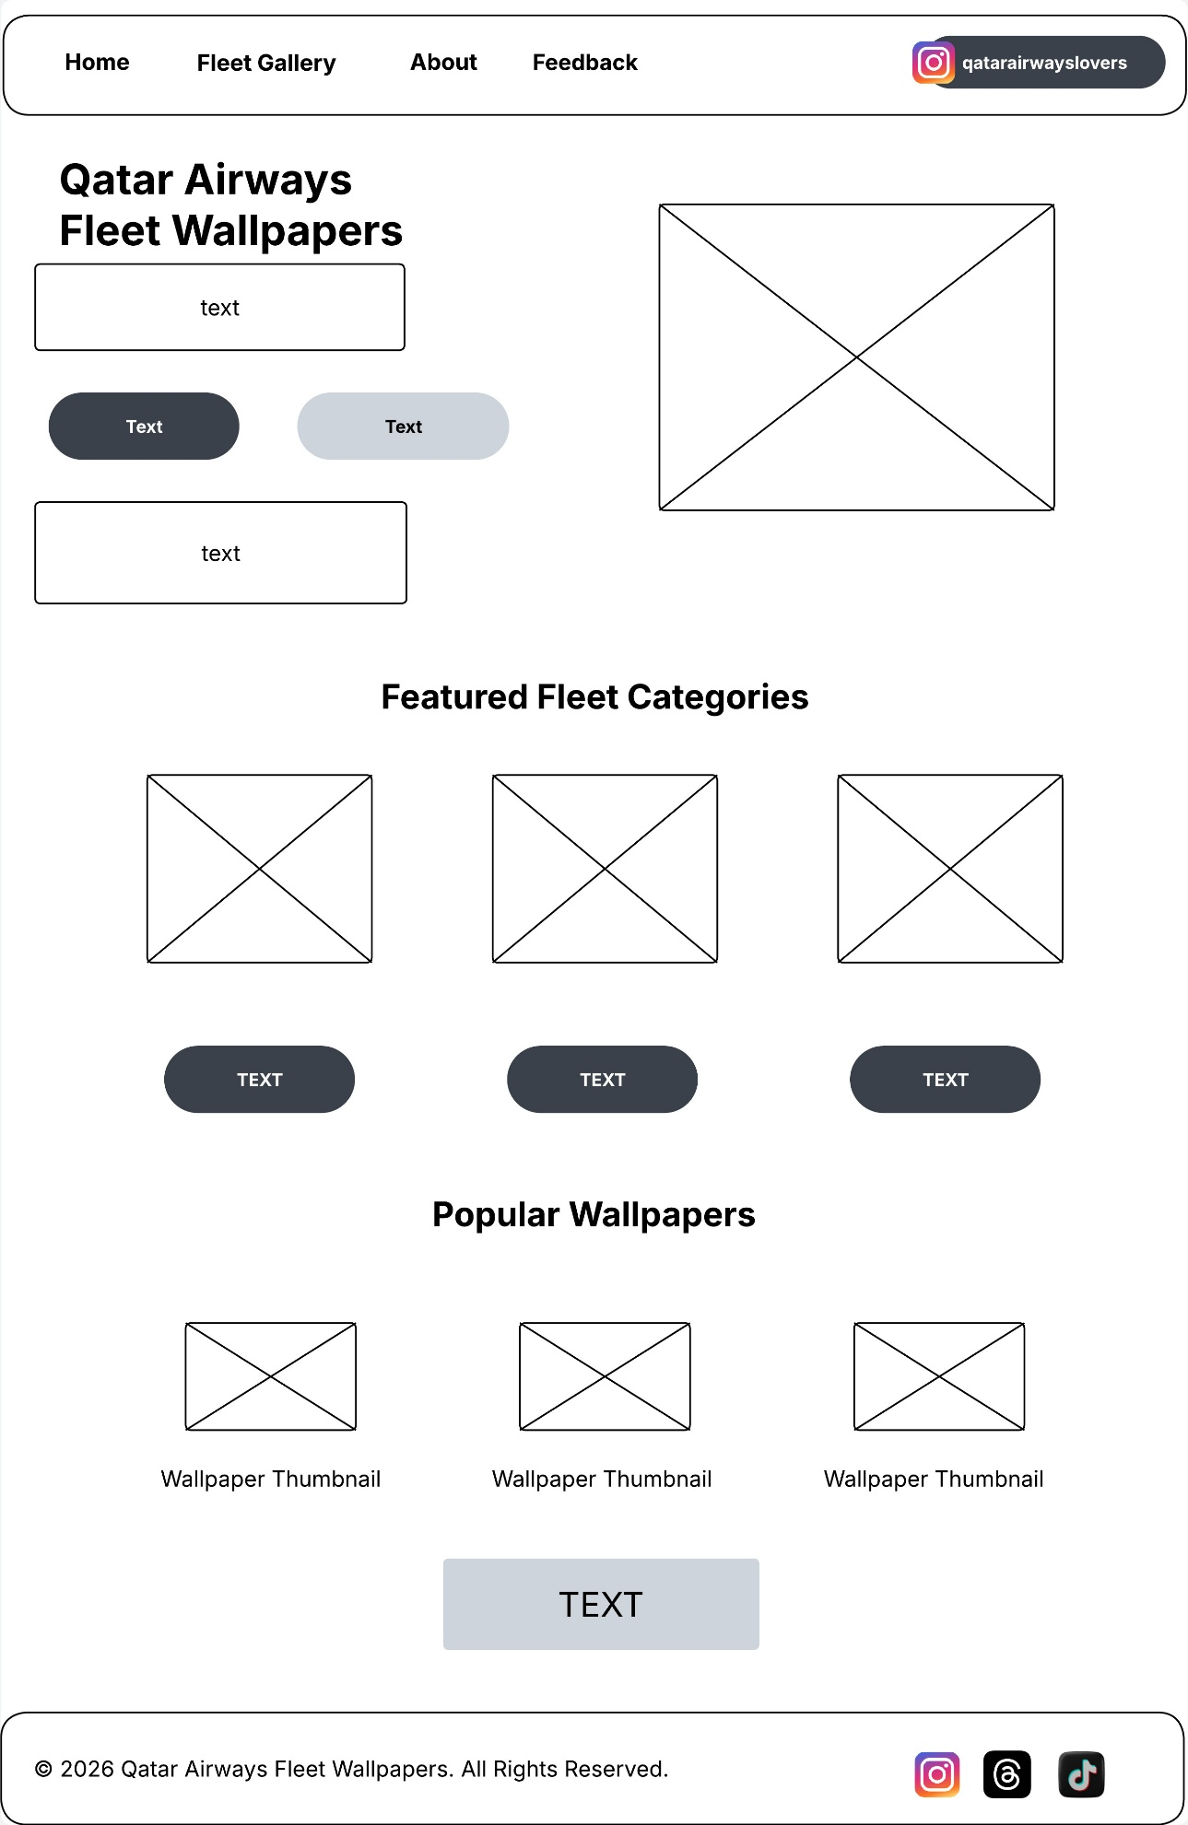
4.2 – Fleet Gallery Wireframe
This wireframe shows the layout of the Fleet Gallery page, which acts as the main category hub for the website. It includes a page title, a search and filter area, a grid of aircraft category cards, and a footer with social media links. The purpose of this layout is to help users browse the Qatar Airways fleet in a clear and organized way before selecting a specific aircraft wallpaper page.
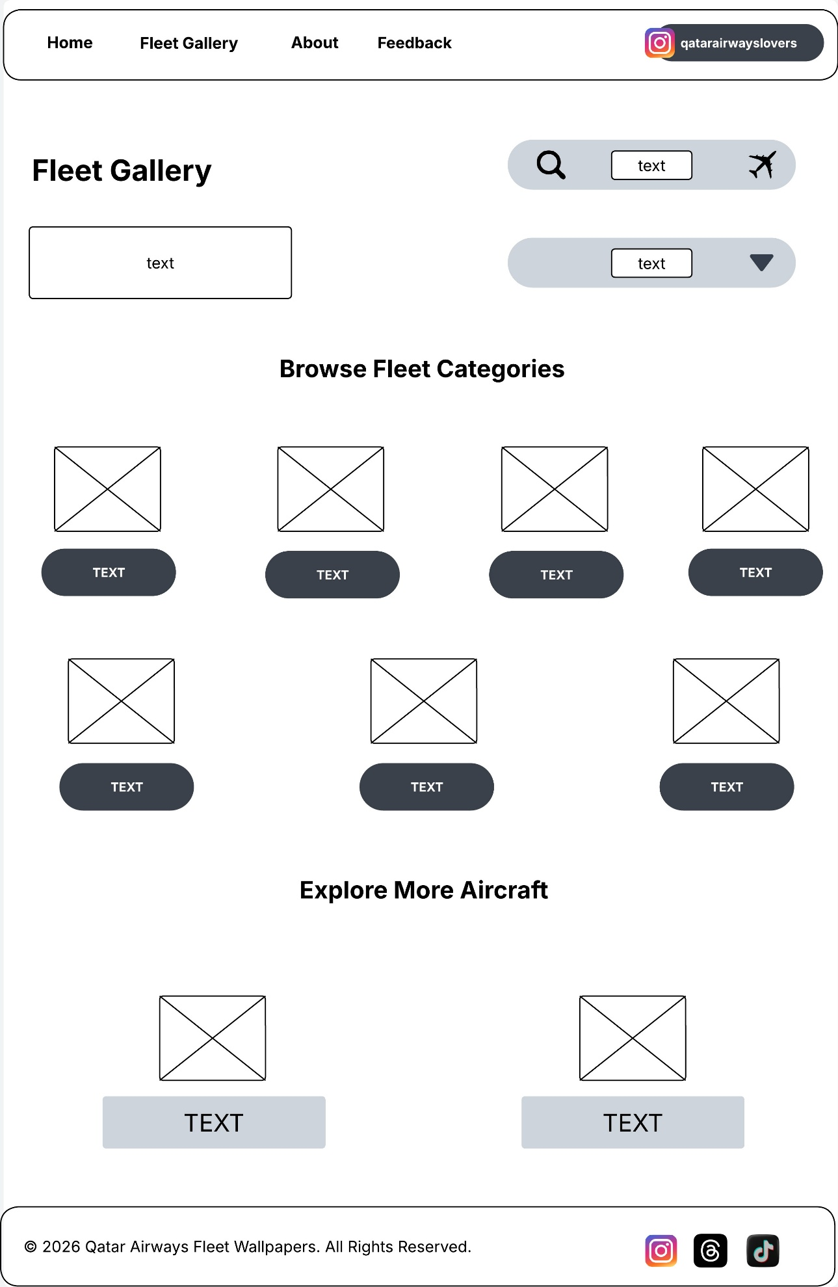

4.3 – About Page Wireframe
This wireframe shows the layout of the About page for the Qatar Airways Fleet Wallpaper website. It includes a page title, an introductory text, an image area, and content sections which explain the purpose of the website, its connection to the existing Instagram aviation fan community known as qatarairwayslovers and insight or information about the creator. The layout is designed to give users a better understanding of the background of the website and the audience it is intended to serve.
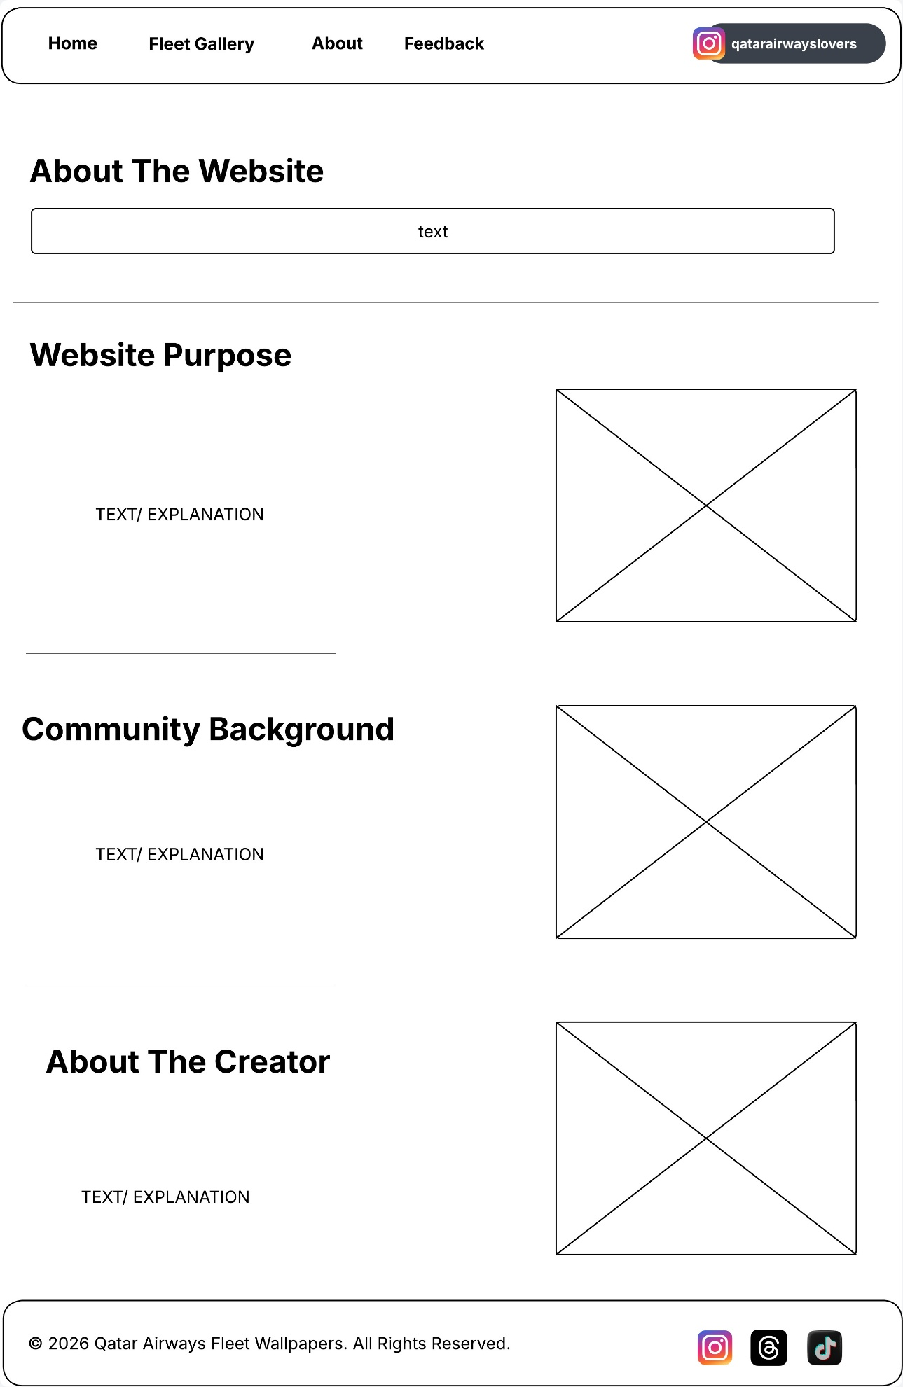

4.4 – Feedback Page Wireframe
This wireframe shows the layout of the Feedback page for the Qatar Airways Fleet Wallpaper website. It includes a page title, introductory text, a feedback form with input fields, a submit button, and a side section containing supporting information. The layout is designed in such a way that allows users to share comments or suggestions easily while keeping the page clear, structured, and user-friendly.
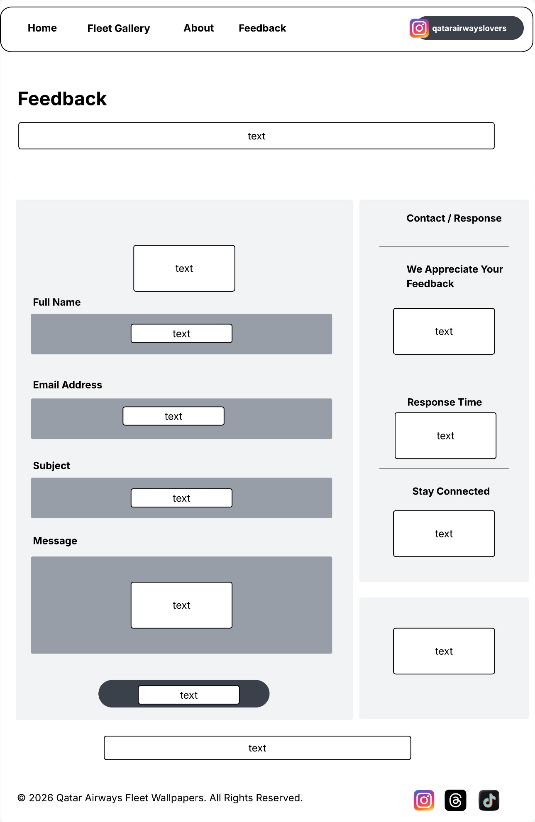
4.5 – Aircraft Detail / Wallpaper Page Wireframe
This wireframe shows the layout of a sample aircraft wallpaper page for the Qatar Airways Fleet Wallpaper website. It includes a large wallpaper preview, wallpaper details, a call-to-action button, a thumbnail gallery, and a related wallpapers section. The layout is intended to represent how individual aircraft pages will be structured across the website and how the users will move from browsing a selected aircraft to the download or mock checkout stage.
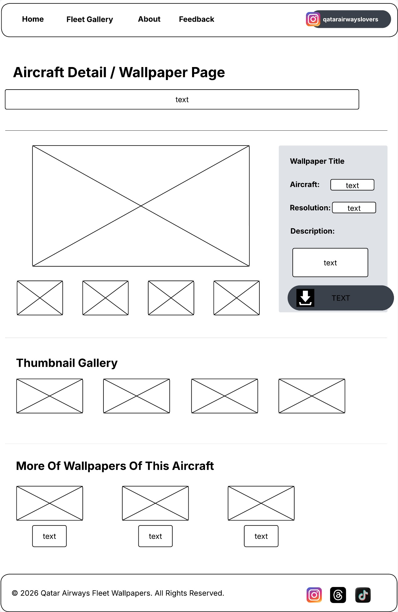
4.6 – Download / Mock Checkout Page Wireframe
This wireframe shows the layout of the Download or Mock Checkout page for the Qatar Airways Fleet Wallpaper website. It includes a selected wallpaper preview, an order summary section, user information fields, a simulated payment method, a confirmation button, and a note indicating that the process is for academic simulation purposes only. The layout is designed to represent the final step of the wallpaper selection process in a clear and structured way.

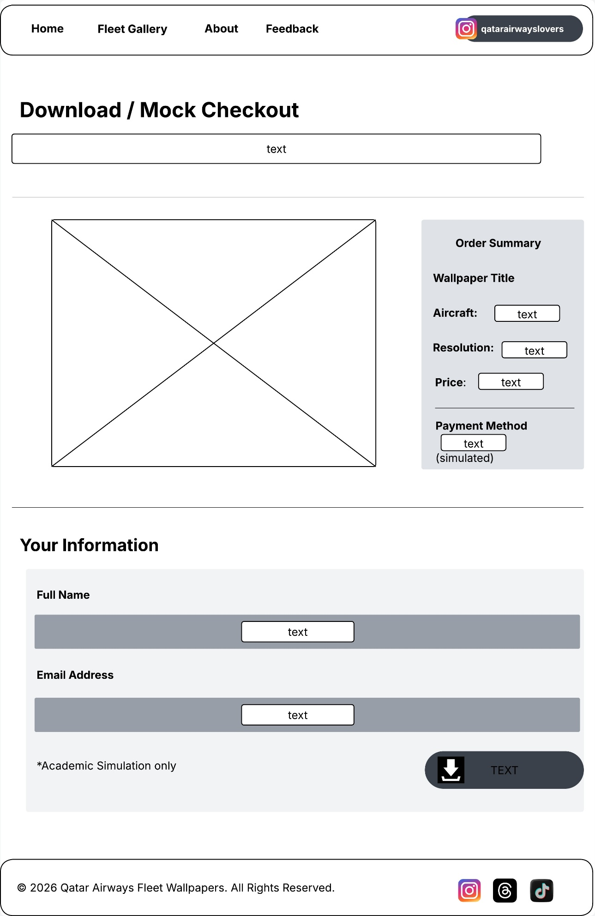
5. Structural HTML 5 Layout

5.1 - <header>
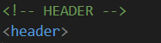
The <header> element functions as the container of introduction for the webpage. It is able to group elements together such as navigation and branding so that browsers and assistive technologies can quickly identify top-level context of the page. When the page loads, the header will typically load first, which allows users immediate access to navigation and key information.

5.2 - <nav>

The <nav> element functions as a dedicated container for the navigation and links. It signals to the browser and assistive technologies that the enclosed links are to be used for page navigation. For example, Screen Readers can jump directly to the navigation section, improving both user accessibility and experience.

5.3 - <main>
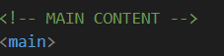
The <main> element is the one that functions as a central container for all unique page content. It ensures that only one main content region exists, helping browsers and assistive tools to be able to distinguish between repeated elements (like headers and footers) and the primary content in the first place. This improves both semantic clarity and accessibility.

5.4 - <section>
The <section> element serves as a thematic way of grouping related content. It divides the page into logical blocks such as “Featured Fleet Wallpapers” or “Popular Wallpapers”. Browsers interpret each section as a distinct content area, which improves document structure and readability.

5.5 - <article>
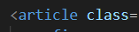
The <article> element functions as a self-contained unit of content. Each article has the ability to stand independently and be reused for distributed outside the page. In your project, each fleet category or wallpaper card is used as its own article which allows it to function as a complete content item.

5.6 - <footer>
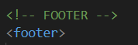
The <footer> element functions as the closing section of the webpage. It groups together secondary information such as copyright notices and social links. It is consistently placed at the bottom which helps users identify the end of the content.

5.7 - <h1>
The <h1> element functions as the highest level heading on the page. It is the one that defines the main topic of the webpage and helps browsers, search engines and assistive technologies to understand the primary purpose of the content.

5.8 - <h2>
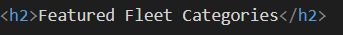
The <h2> element functions as a secondary heading used to divide content into major sections. It creates a clear hierarchy under the <h1>, allowing users to scan and understand the page structure properly.

5.9 - <h3>
The <h3> element functions as a subheading within sections. It is used to label smaller content groups, such as individual cards, helping to organize content into a more structured hierarchy.

5.1.1 - <p>

The <p> element functions as a container for textual content. It ensures that text is displayed in a readable format that has the proper spacing and structure which in overall makes the content easier to understand.

5.1.2 - <img>
The <img> element functions as a self-contained media element used to display images. It is the one that loads visual content into the page and supports attributes such as alt, which provides alternative text for accessibility improves usability for screen users.

5.1.3 - <button>
The <button> element functions as an interactive control that allows users to be able to perform actions. It responds to user input such as clicks and can be used for navigation or triggering events which improves interactivity on the page.

5.1.4 - <figure>
The <figure> element functions as a container for media content along with its associated description. It groups visual elements together which makes it clear that the image and its caption are related.

5.1.5 - <figcaption>
The <figcaption> element functions as a descriptive label for the content that is found in <figure>. It provides context for images, helping users understand what the image is representing and improves accessibility.

6. Presentation Layer – CSS 3, Bootstrap, and Javascript
6.1 - Introduction
The visual design of the website was inspired by the Qatar Airways Lovers aviation community logo and the official Qatar Airways branding identity. This comes with a combination of maroon backgrounds and gold accent colors was used to create a luxury aviation atmosphere which is a reflection of the airline branding and modern multimedia presentation.
The website was basically designed to have that cinematic, modern, interactive and visually engaging feel while still maintaining a clean and professional user interface.

The presentation layer was developed using:
- HTML5
- CSS3
- Bootstrap 5
- JavaScript

6.2 – CSS3 Implementation
CSS3 was used throughout the website to improve:
- Visual styling
- User interaction
- Animations
- Responsiveness
- Layout Control
- Transitions

6.3 – CSS Variables
CSS variables improve scalability and maintainability because branding colors can be changed globally from one location instead of going through the tedious work of editing multiple CSS rules individually.

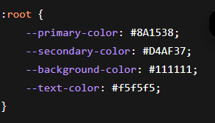

The maroon and gold color palette was selected to match the current Qatar Airways Lovers community branding and create a premium aviation-inspired appearance throughout the entire website.
Using CSS variables reduces the use of repetitive code and improves the visual consistency across all pages.

6.4 – CSS Selectors
CSS selectors were used to target specific HTML elements for the purpose of styling.
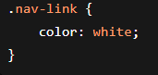
Selectors allow styles to be applied to specific components of a website. In the above example, the .nav-link selector styles all navigation links used inside the website navigation bar.
Selectors also improve how things are organized and allow styling consistency throughout the website interface.

6.5 – Hover Effects and Transitions
Hover effects and transactions were implemented in order to improve interactivity and provide immediate visual feedback whenever users interact with website elements.
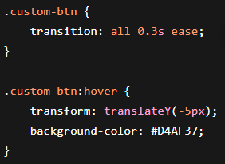
Smooth hover animation were applied to:
- Navigation links
- Button
- Gallery images
- Wallpaper cards
This improves
- User engagement
- Modern multimedia presentation
- Website responsiveness
Transitions also present animations from appearing suddenly by creating a smoother movement throughout the interface.

6.6 – CSS Transform
CSS transforms were used to animate wallpaper cards.
.fleet-card:hover {
transform: scale(1.03);
}
The transform property enlarges the wallpaper cards just slightly whenever users hover over them.
This creates an emphasis on selected multimedia content and improves interaction within the wallpaper gallery section.
Transformations also contribute to a more modern and professional visual presentation.

6.7 – Keyframe Animation
Keyframe animations were used to create fade-in effects on sections and images.
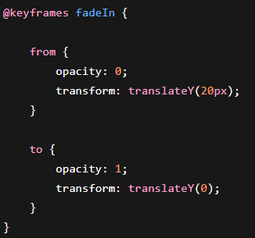
The fade-in animation allows the sections to appear gradually as the page loads.
This improves the cinematic appearance of the homepage together with pages that may be involved and enhances the presentation of the aviation wallpapers.
Animations also improve the user engagement by making the website feel more dynamic and interactive.
6.8 – Flexbox Layout
Flexbox was used because it allows the website to be able to align dynamically while maintaining proper spacing and positioning.
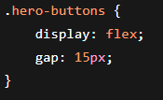
Flexbox was particularly useful in the hero section where action buttons needed to remain aligned consistently across different screen sizes.
This improved:
- Responsive behavior
- Spacing consistency
- Layout Flexibility

6.9 – Media Queries
Media queries were implemented to improve the responsiveness on a much smaller device.
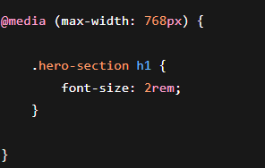
Media queries allow the website layout to adapt to smaller screen sizes such tablets and smartphones.
This improves:
- Accessibility
- Responsive design
- Readability
Media queries ensure that text and layouts remain usable across different devices.

6.2.1 – Overlay Effect
Overlay Effects were used on wallpaper cards.
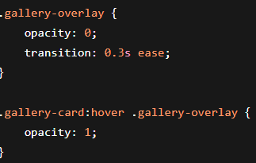
Overlay effects improve user engagement by displaying interactive visual layers on wallpaper cards without overcrowding the interface.
This creates much cleaner multimedia presentation while emphasizing wallpaper previews whenever users hover over gallery images.
The overlay effect also improves the visual hierarchy by drawing attention towards selectable multimedia content.

6.2.2 – Bootstrap 5 Implementation
Bootstrap version 5.3.3 was selected because it simplifies responsive design implementation while providing reusable UI components that reduce development time.
Bootstrap improved:

- layout consistency
- responsive behavior
- spacing management
- navigation structure
- form responsiveness

The framework also made it easier to create layouts that adapt effectively across desktops, tablets, and smartphones.

6.2.3 – Bootstrap Navbar
Bootstrap’s responsive navbar component was used for website navigation.
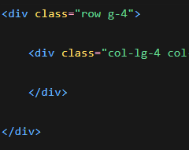
The Bootstrap navbar automatically adapts across different screen sizes.

The navbar-expand-lg class ensures that navigation links collapse into a mobile menu on smaller devices.

This improves:

- usability
- navigation accessibility
- responsive behavior

6.2.4 – Bootstrap Grid System
The Bootstrap grid system was important because it automatically reorganizes website content depending on screen size.
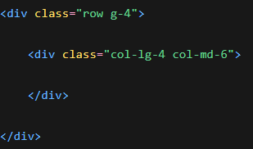
Wallpaper gallery cards were placed inside responsive Bootstrap columns to maintain balanced layouts across:

- desktop devices
- tablets
- smartphones

This improves:

- accessibility
- responsiveness
- content organization
- user experience

6.2.5 – Bootstrap Utility Classes
Bootstrap utility classes were used to improve spacing and alignment.
Utility classes reduce the need for excessive custom CSS.

They were used throughout the website to:

- center content
- add spacing
- improve responsiveness
- resize images automatically

This improved development efficiency and layout consistency.

6.2.6 - Bootstrap Buttons

Bootstrap buttons were customized using CSS.

<button class="btn custom-btn">

Bootstrap button classes provide reusable and responsive button styling.

Additional custom CSS was applied to match the Qatar Airways visual identity using:

- maroon backgrounds
- gold hover effects
- smooth animations

Buttons were used throughout the website for:

- browsing wallpapers
- downloads
- feedback submission

6.2.7 – Bootstrap Forms
Bootstrap forms were implemented for the feedback and download sections.

Bootstrap form classes improve input styling while maintaining responsive layouts.

Forms were used to simulate:

- feedback submission
- wallpaper download interaction

Using Bootstrap forms improved:

- layout consistency
- responsiveness
- usability
- visual organization

6.2.8 – JavaScript Functions
JavaScript functions were used to improve modularity and code reusability throughout the website.
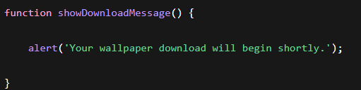
Functions were implemented for:

- wallpaper download simulations
- feedback confirmation messages
- form validation
- interactive alerts

Using reusable functions improves:

- code organization
- maintainability
- readability

6.2.9 – DOM Manipulation
DOM manipulation was implemented using JavaScript selectors such as:

- querySelector
- querySelectorAll

This allowed the website to dynamically interact with:

- buttons
- forms
- wallpaper cards
- interactive sections

DOM manipulation improves user interaction by allowing website elements to respond dynamically without requiring page reloads.

6.3.1 – Event Listeners
Event listeners were used to detect user interactions such as:
- button clicks
- form submissions
- download interactions

This improves interactivity by allowing the website to respond immediately whenever users interact with interface components.

Event listeners were implemented for:

- feedback buttons
- wallpaper download buttons
- interactive form behavior

6.3.2 - Form Validation
Form validation was implemented in both the feedback section and the wallpaper download section.

Validation ensures that users complete required fields before submitting forms.

This improves:
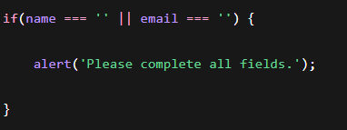
- data quality
- usability
- user guidance
- interaction reliability

Immediate feedback messages were also implemented to notify users whenever information is missing.

6.3.3 – Feedback Confirmation Interaction
This JavaScript interaction was implemented to provide immediate confirmation whenever users submit feedback through the website.

The confirmation message improves:

- behavioral feedback
- usability
- interactivity
- user reassurance
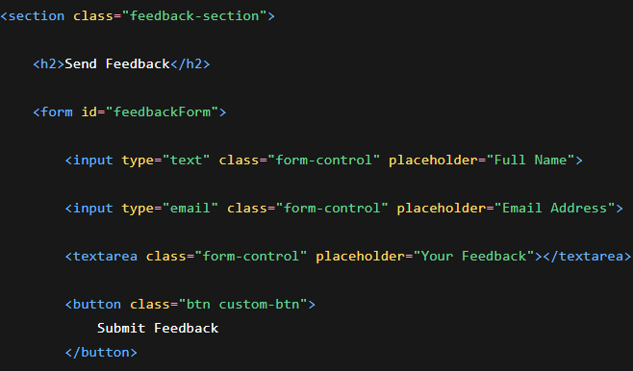

Providing confirmation alerts also improves the professionalism of the website by informing users that their submission was successful.

The event listener detects the button click and triggers the confirmation message dynamically using JavaScript.

6.3.4 - Scroll Animation Trigger
JavaScript was used to trigger animations when sections become visible on screen.
IntersectionObserver was used to trigger animations when sections become visible on screen, improving performance and user experience.

This approach prevents unnecessary animations from running continuously and creates smoother multimedia transitions during scrolling.

6.3.5 – Responsive Design
Responsive design was a major focus throughout the implementation of the website.

The interface was designed to adapt effectively across:

- desktop devices
- tablets
- smartphones

Responsive techniques used throughout the website included:

Bootstrap grids
- media queries
- responsive typography
- flexible images
- responsive navigation menus

This ensures that users receive a consistent and accessible multimedia experience regardless of device size.

